Module: | Schedule of Classes Records
Business Process Name: | How to Create a Skip Meeting Pattern Section
Created By: | Debbi Busack
Creation Date: | 5/29/18

Business Process Summary

This guide reviews how to create a Skip Meeting Pattern Section. THIS IS ONLY ALLOWED FOR SOUTH CAMPUS SECTIONS. This process allows SOUTH sections to be combined that have different locations, facility id, instructors, assignment loads and/or meeting patterns.
When editing a meeting pattern, you will need to go to every single meeting pattern separately to make a change.

NOTE – If you ever have to make a change in one of the meeting patterns, it will wipe out ALL the meeting patterns in the combination.

Business Process Procedures:

Step A | Action— Adding a Skip Meeting Pattern Course
Navigate to the course in Course Catalog. UAccess Login. Administrative Staff>Navigator>Curriculum Management>Course Catalog>Course Catalog. (For more details, please review BPG-How to review the Course Catalog?
- Check that it is Active
- Check Catalog Data
- Min & Max Units
- Repeat for Credit
- Allow Multiple in Term
- Cross listings - If the course is cross listed, write down all cross listed subjects, you will need to add a course for EACH cross listing.
- Check Components
- Components (Required & Optional)
2. | Navigate to the Schedule of Classes. Administrative Staff>Navigator>Curriculum Management>Schedule of Classes>Schedule New Course, or if sections already exist use Maintain Section of Classes.  In order to combine two or more courses (necessary when using skip meeting pattern), the section of each course will need to have an existing Class Nbr with the same Term and Session in order to place together in a combination.
3. | Search by Term, Subject Area, and Catalog Nbr.  On Basic Data tab, if there are no sections, simply begin by entering in the information. If there are already existing sections, that you need to click the plus button to the right.  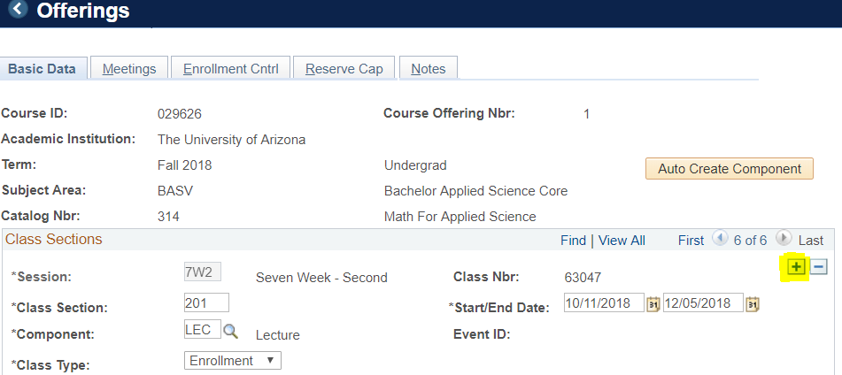  Schedule of Classes Checklist: “Basic Data”  - Session - Regular Academic Session or 7W1 or 5W2, etc  - Section - as requested.  - Associated Class should match Section (without the leading zeros).  - Class Type – As requested  - Campus - “SOUTH” or “DIST”  - Location - there are many choices, click on the spyglass to see your choices and choose the one the section is requesting, example ”Sierra Vista” or “Yuma” or “Ft Huachuca” etc.  - Instruction Mode - click on the spyglass to see your choices and choose the one the section is requesting, example “IT” or “HY”  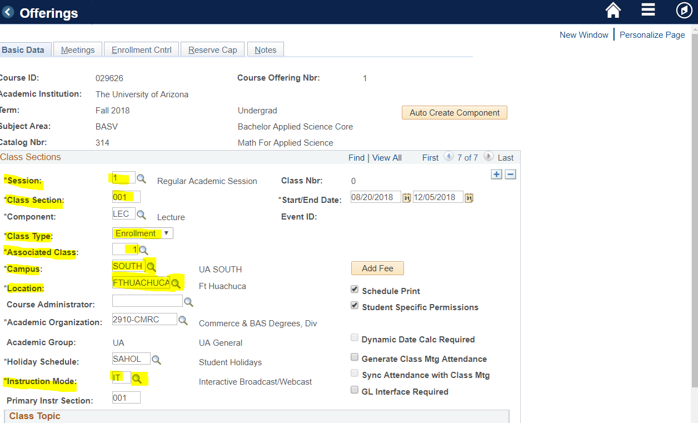
4. | Go to the “Meetings” tab  NOTE: If you add Instructor first, it will transfer to the next meeting pattern when you click the plus button to add another meeting pattern.  - Instructor  - click on spyglass, type in last name of instructor and click “Look Up” A list of instructor will appear with that last name, double click on the instructor name. If the instructor name does not appear see BPG for “Adding Instructor to Instructor Table”  - Click on the drop down box for Instructor Role and click “Pri Instr” or “Dep Adm” or “TA”  - Make sure the “Print” box is checked  - For “Access” click the drop down box and click “Post”  - Click “Save”  - Facility ID (Fill in Dept Controlled Rooms if given)  - Typically these have an online portion and in person or IT portion, therefore you will need more than 1 meeting pattern  - For the first 999-Online meeting pattern - type in “999-Online” for Facility ID - Do not put in any times. Make sure the start/End Date are correct.  - Click the PLUS button  - Add Facility ID, example “11008-9”  - Add Mtg Start and End time Example “5:30 PM - 8:00 PM”  - Check the box or boxes for the day or days of the week the class will meet.  - Note - the End time automatically defaults to one hour after the start time, so be sure and change to the correct end time and tab over to make sure it saves the correct end time.  - Start/End Date - These are sometimes individual dates, possibly once per month or every other week or completely random and therefore each date will need to be added as a separate meeting pattern by clicking the plus button and entering info for EACH date.  - To make the above easier, you may click “View All” and all the meeting patterns will be shown or added on the same page, allowing you to cut and paste, Facility ID, times, etc.  - Click SAVE  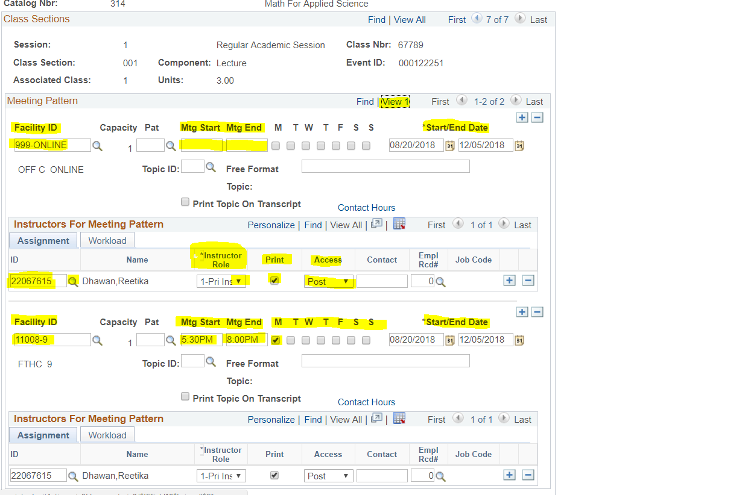
5. | Go to “Enrollment Cntrl” tab  - Class Status - Make sure it says “Active”  - Add Consent - Only change this if they have marked the “Add Consent” checkbox on the request form  - Drop Consent - Only change this if they have marked the “Drop Consent” checkbox on the request form  - Requested Room Capacity - change to the size of the classroom the section needs, if they using a departmentally controlled room put “1”  - Enrollment Capacity - Obtain this number from the section form  - Click SAVE  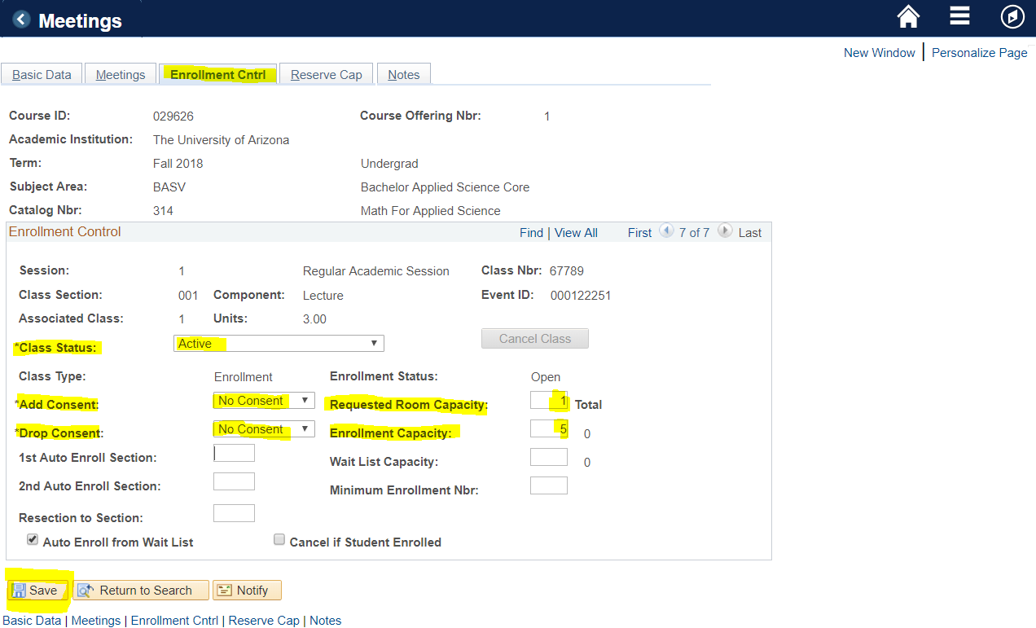  Please note that this is where departments can manipulate enrollment numbers between courses that are Combined. For example, if there should be 10 in Sierra Vista and only 5 students at Ft Huachuca then set individual enrollment caps to 10 for Sierra Vista and 5 for Ft Huachuca, while setting the combined Enrollment Cap to 30  Most likely, you will see a pop up box Message, with a warning stating that the instructor is scheduled to print on the Schedule of classes 2 or more times. Simply click “OK” You may have to do this many times on several screens.  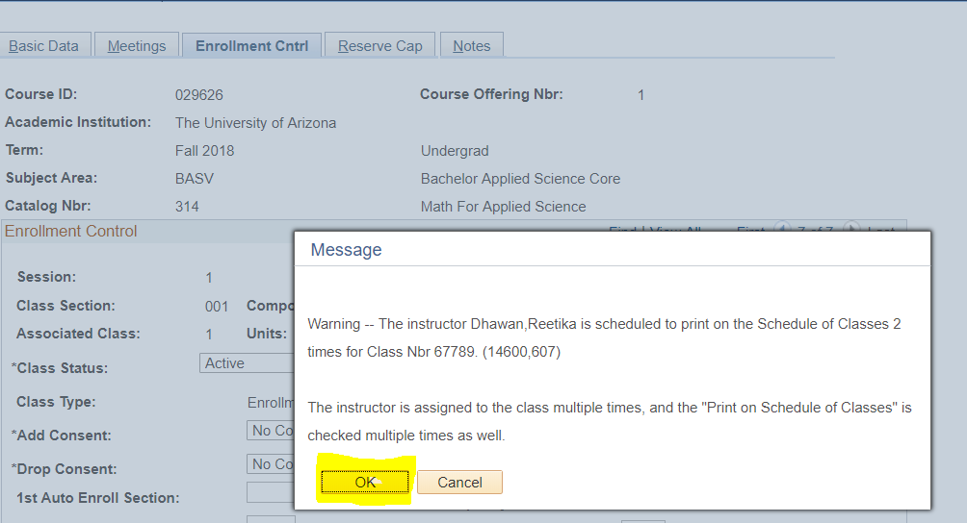
6. | Write down the class number for that section.
7. | If requested to add Requirement Group (RG), go to Adjust Class Association screen.  See BPG: How to Add Requirement Group?
8. | Repeat steps 3-6 for each individual section
10. | Combined Sections:  Once each section (Example - section 001 Ft Huachuca, section 002 Sierra Vista, etc) has been individually added to the Schedule of Classes and is assigned a Class Nbr navigate to Curriculum Management> Combined Sections> Combined Sections Table.  - Input the correct Term and Session, then hit search.  - Press the plus sign to add a new combination to the Combined Sections Table  (Please note: Never press the plus sign on the first Combined Sections ID that appears).  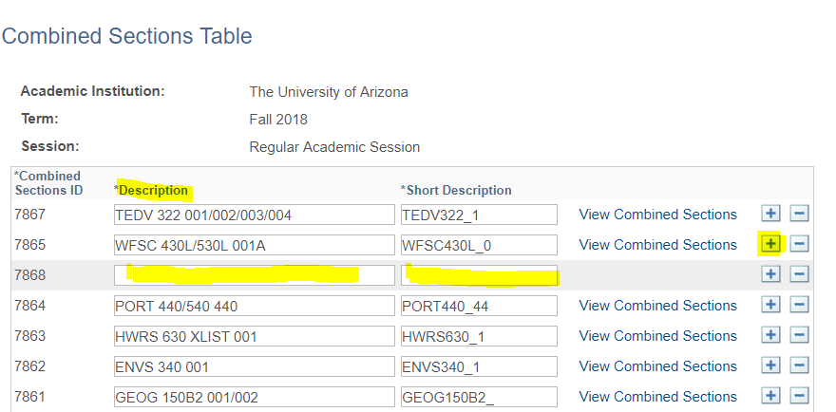  - Input the Description and Short Description  The Description of the course should be:  Subject, Catalog Nbr’s (in order from smallest to greatest), and Section number (in order from smallest to greatest). Example - BASV 314 001/002  The Short Description is:  Subject (followed by no space), smallest corresponding Catablog Nbr (followed by an underscore), and corresponding Section number. Example - BASV314_1  Once Descriptions are input,  - Scroll all the way down to the bottom of the page and save OR push the ALT button and the number 1 button at the same time and look for the “Saving” box that appears at the top right of the page.  - The blue “View Combined Sections” will appear next to the description you just added.
11. | Every time a new combination has been created it is given a unique Combined Sections ID specific to Term and Session. After saving the Descriptions, go to the correct Combined Sections ID and select “View Combined Sections” to input Class Nbr’s.  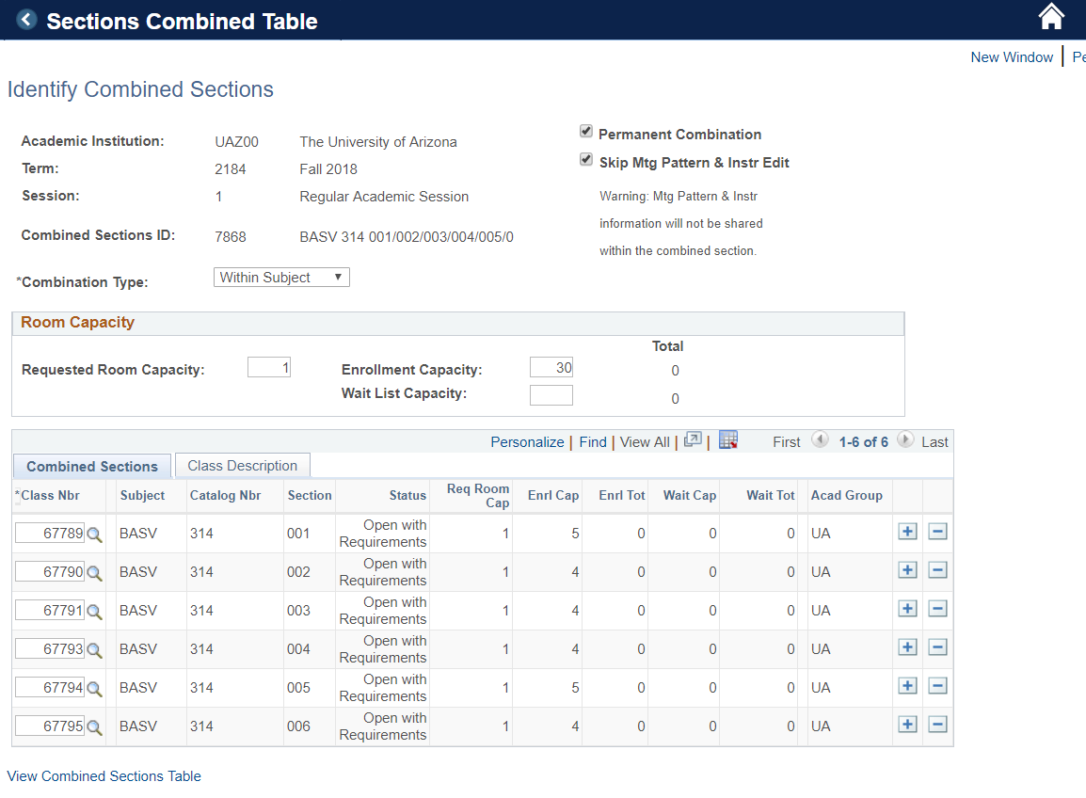
12. | - Add the corresponding Class Nbr’s for the courses associated to the combination. .  - After you input a Class Nbr press the plus sign to input the next Class Nbr. Repeat until you have input all classes that should be in the combination.  - Iinsert a Requested Room Capacity -Enter a “1” if departmentally controlled room.  - Combined Enrollment Capacity - this number you will need to get from the Dep rep if they don’t note it on the form.  - Wait List Capacity (if offered)  - Put a check mark in the SKIP MTG PATTERN AND INSTR EDIT box  After having all Class Nbr’s in the combination,  - Save  - Write down the Combined Sections ID number (underlined in green below).  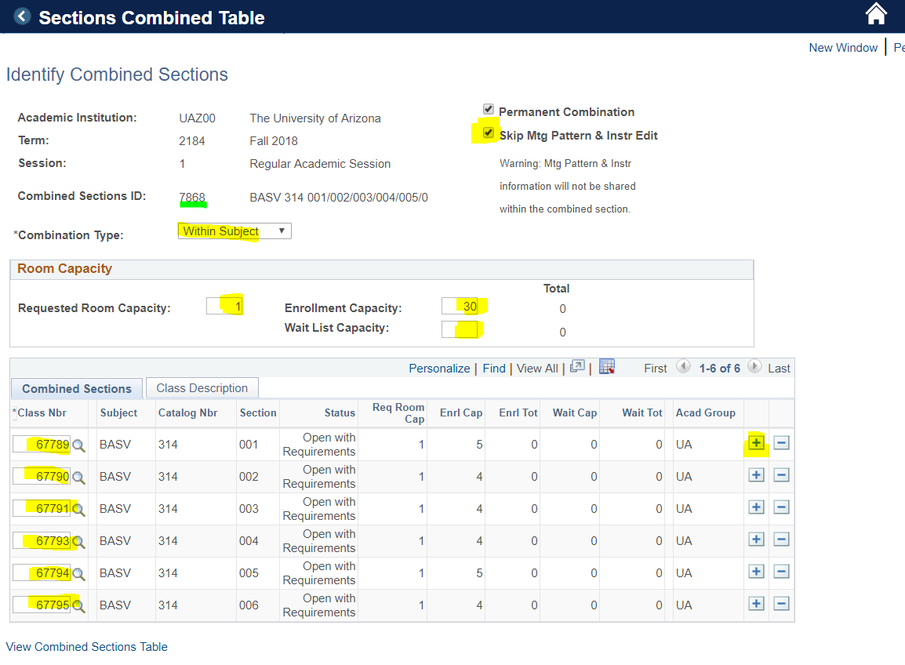
13. | Now go back into your form and select “Admin Notes”  - Type in everything you have done.  Example:  Class Nbr: 67789  2184 Reg Session  SOUTH, Ft HUACHUCA  IT  999-Online  M 5:30-8  11008-9  Instr: Dhawan Prim, Print, Post  Enr Cap: 5  Req Grp: 015621  Combined w/ sections:  002 - class nbr: 67790  003 - class nbr: 67791  004 - class nbr: 67793  005 - class nbr 67794  006 - class nbr 67795  Comb ID: 7868  Combined Enr Cap: 30  Skip Mtg Pattern Box checked  - Copy the info you just put in to use as a template for all section form Admin Notes and simply change the information pertaining to each section - ie. class nbr, location, enr cap, RG, combined with.  - Click ” Update Admin Notes”  - Click the drop down box for “Complete”  - Click “Update”  - Click “Check In and Return”

