Module: | Schedule of Classes Records
Business Process Name: | How to Add New Co-Convened, Cross-Listed Section
Created By: | Marco Quintero
Creation Date: | 5/22/18

Business Process Summary

This guide reviews how to create an in-person section to a course that is being Co-Convened with another course that is Cross-Listed. Typically this occurs between an undergraduate and graduate course (400/500 level) with one of those (if not both) being Cross-Listed in the Course Catalog. They are section numbers from 001-099 and 300-499.

Business Process Procedures:

Step A | Action— Adding a Cross-Listed, Co-Convened Section
Navigate to the course in Course Catalog. UAccess Login. Administrative Staff>Navigator>Curriculum Management>Course Catalog>Course Catalog. (For more details, please review BPG-How to review the Course Catalog?)
- Check that it is Active
- Check Catalog Data
  - Min & Max Units
  - Repeat for Credit
  - Allow Multiple in Term
  - Cross listings
- Check Components
  - Components (Required & Optional)

Check Course Catalog for both undergraduate and graduate courses being combined to check if they have cross-listings.
Navigate to the Schedule of Classes. Administrative Staff>Navigator>Curriculum Management>Schedule of Classes>Schedule New Course, or if sections already exist use Maintain Section of Classes.

In order to Co-Convene two courses (400/500) that have Cross-Listings, the two sections along with their cross-lists will need to have an existing Class Nbr with the same Term and Session in order to put in combination.
Search by Term, Subject Area, and Catalog Nbr. On Basic Data tab add section number 001-099 or 300-499 as requested. Associated Class should match (without the leading zeros). Campus “Main”, Location “Tucson”, and Instruction Mode “In Person”.

Go to Basic Data tab:

Each Co-Conneved section 400/500 must add their individual Cross-Listings with same “Basic Data” tab information. The 400 and 500 level courses should match also.

Schedule of Classes Checklist: “Basic Data”
- Session
- Section & Associated Class
- Class Type
- Campus & Location
- Instruction Mode

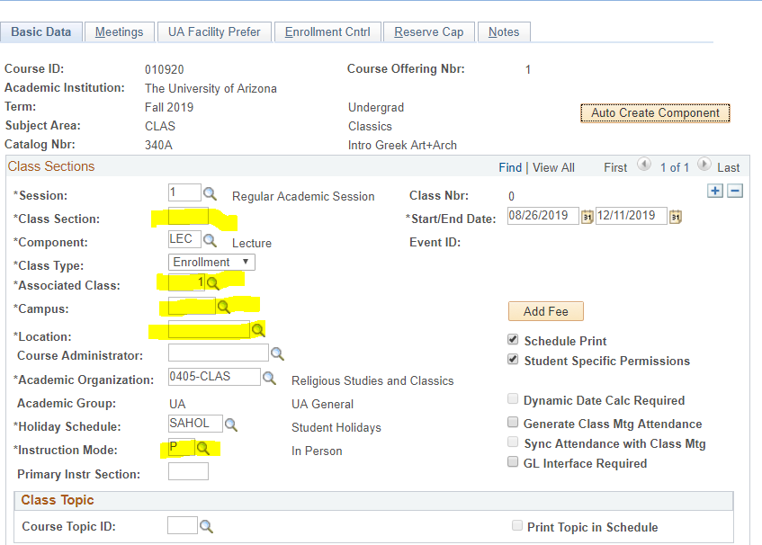

After creating each 400/500, cross-listed section write or copy down the “Class Nbr” to make the combination process easier at the end. You will eventually need these Class Nbr’s to create a combination.

(For more details, please go to BPG- How to Manage Basic Data Tab in the Schedule of Classes).
Go to Meetings tab:

Schedule of Classes Checklist: “Meetings” (If Combined, do this last).
- Facility ID (Fill in Dept Controlled Rooms, Leave empty for Centrally Scheduled Classrooms)
- Standard Meeting Pattern
- Instructor

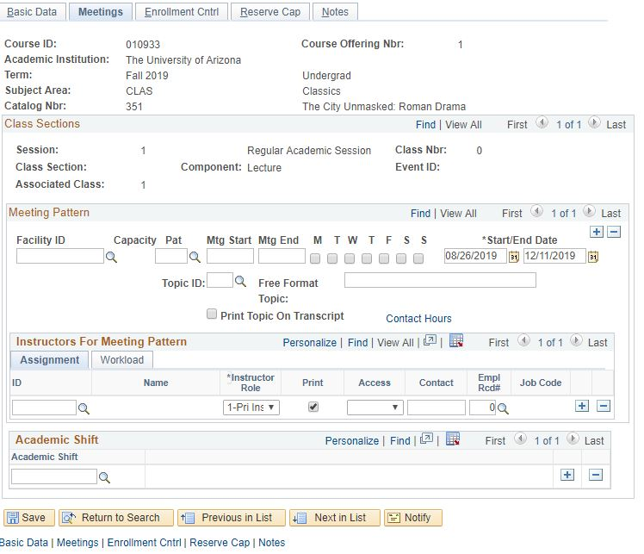

(For more details, please go to BPG- How to Manage Meetings Tab in the Schedule of Classes).
Go to Enrollment tab:

Schedule of Classes Checklist: “Enrollment Cntrl”
- Class Status
- Add Consent
- Drop Consent
- Requested Room Capacity
- Enrollment Capacity

*This is where departments can manipulate individual enrollment numbers between undergraduate and graduate courses that are Co-Convened. For example, if there should be 25 undergrad and only 5 graduate students in the course then set individual enrollment caps to 25 for the undergraduate and 5 for the graduate course, while setting the combined Enrollment Cap to 30 (step 9).

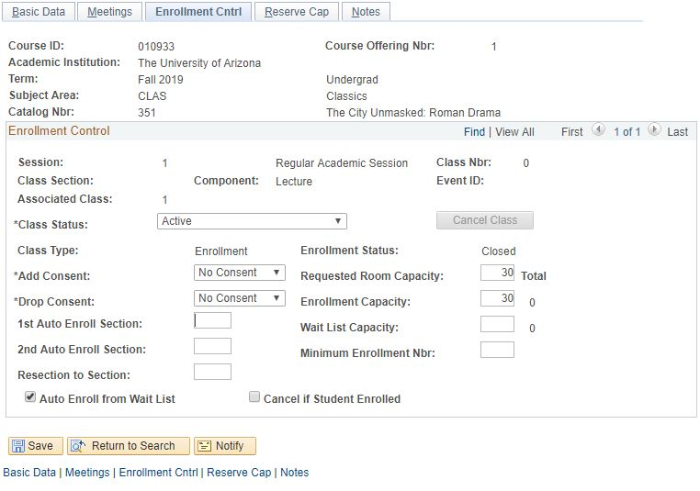

(For more details, please go to BPG- How to Manage Enrollment Tab in the Schedule of Classes).
Go to the Reserve Cap tab:

Schedule of Classes Checklist: “Reserve Cap”

- Reserve Capacity: As requested
- Reserve Capacity Sequence: As requested
- Enrollment Total: As requested
- Start Date: As requested
- Requirement Group: As requested
. Cap Enrl: As requested

(For more details, please go to BPG- How to Manage Reserve Cap Tab in the Schedule of Classes).

Go to Notes tab:

Schedule of Classes Checklist: “Notes”
- Note Nbr: As requested
- Free Format Text: As requested

(For more details, please go to BPG- How to Manage Notes Tab in the Schedule of Classes).

Remember!

- For Cross-Listed sections, repeat steps 3-7 of this BPG for each cross-listing (secondary courses)! Check for both Undergraduate and Graduate courses.

- Only after you set up each section in the cross-listing, you can move to step 9 of this BPG.

Combined Sections:

Navigate to Curriculum Management> Combined Sections> Combined Sections Table. Input the correct Term and Session, then hit search.

- Add a New Row
  - Press the plus sign to add a new combination to the Combined Sections Table (Please note: Never press the plus sign on the first Combined Sections ID that appears).

    - The Desciption of the course should be:
Subject Catablog# XLIST Section#

- The Short Descirption is:
SubjectCatablog#_Section#

Once Descitption’s are inputted, scroll to the bottom and save.

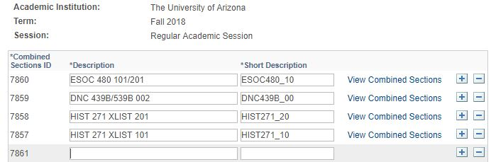
Every time a new combination has been created it is given a unique Combined Sections ID specific to Term and Session. After saving the Descriptions, go to the correct Combined Sections ID and select “View Combined Sections” to input Class Nbr’s.

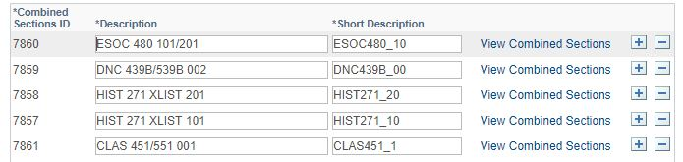

Input the Class Nbr’s for the home dept’s and cross-listings associated to the combination.

Be sure to insert a
Requested Room Capapcity
    - Centrally Scheduled Classroom: greater or equal to 15
    - Dept. Scheduled Classroom: Change to 1
    - Online: Change to 1
Combined Enrollment Capacity
    - As requested
Wait List Capacity
    - As requested

After inputting a Class Nbr, press the plus sign to input a second (third, forth, etc.) Class Nbr from the list you copied down during Step 3.

After placing all Class Nbr’s that need to be cross-listed in the combination, Save.

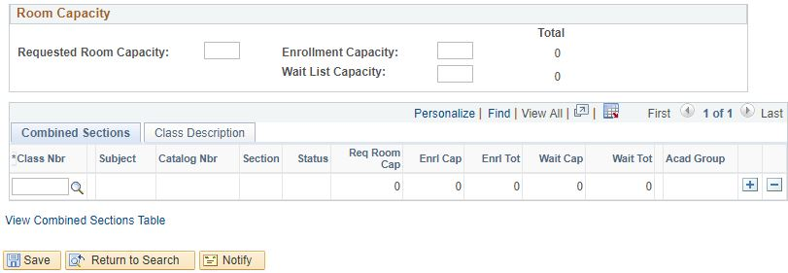
Navigate to Curriculum Management>Schedule of Classes>Schedule Class Meetings.
- Filter by Term, Subject Area, and Catalog Nbr.

Go to the Meetings tab:

Schedule of Classes Checklist: “Meetings”
- Facility ID:
  - Centrally Scheduled Classroom: Leave blank
  - Dept. Scheduled Classroom: Place your classroom in here
  - Online: Place 999-ONLINE here
- Standard Meeting Pattern:
  - Centrally Scheduled Classroom: Place standard meeting pattern
  - Dept. Scheduled Classroom: Place any meeting pattern
  - Online: Place any meeting pattern or leave blank
- Instructor: You may enter employees ID, if you don’t have employees ID in hand you can search instructors first or last name by pressing the magnifying glass. Make sure to give at least one individual post access in “Instructors for Meeting Pattern”.
- Room Characteristics:
  - Centrally Scheduled Classroom: Select room characteristics you need by using the magnifying glass.
  - Dept. Scheduled Classroom: Leave blank
  - Online: Leave blank

(For more details, please go to BPG- How to Manage Meetings Tab in the Schedule of Classes).

*Only under the “Schedule Class Meetings” tab can meeting patterns and instructor information be changed for cross-listed sections. Changing the meeting pattern and Instructor information here will change it for all cross-listed sections in combination.

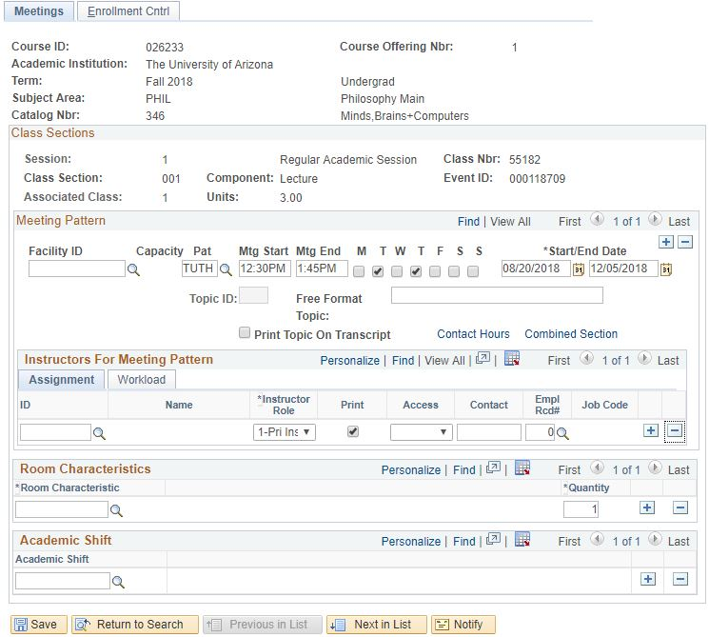
 | Save & Done!
TIPS & TRICKS

  - If a section is in a combination, if will have Combined Section appear until the meeting tab, see it circled in red below.

